**LAB#04**

**Complex.h**

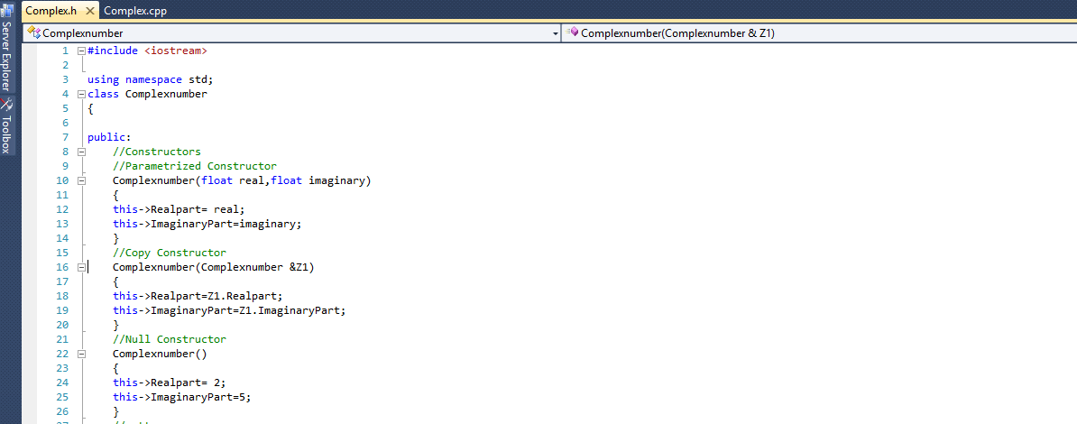

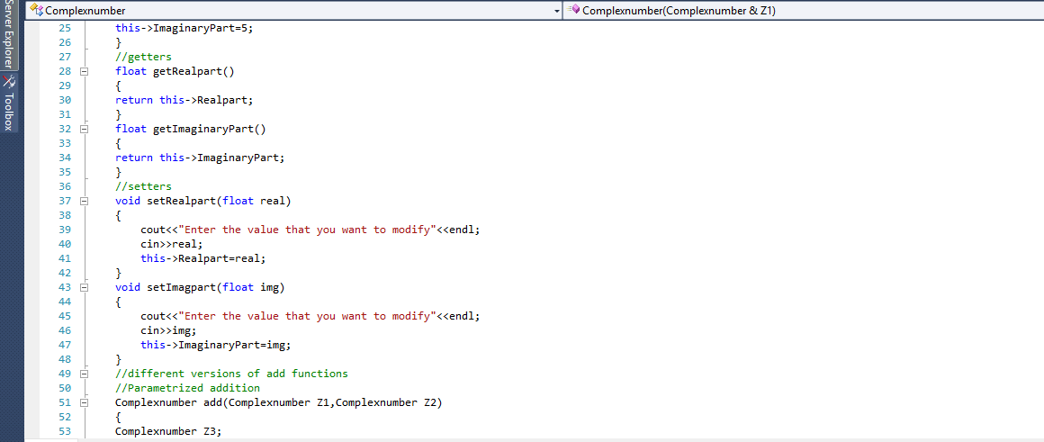

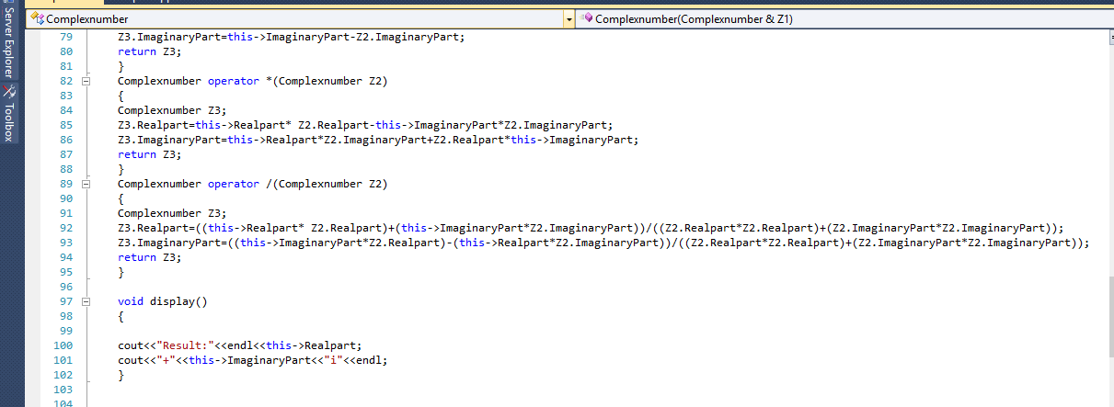

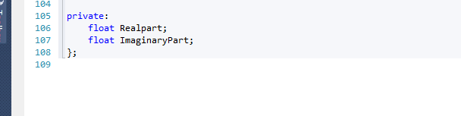

**Complex.cpp**

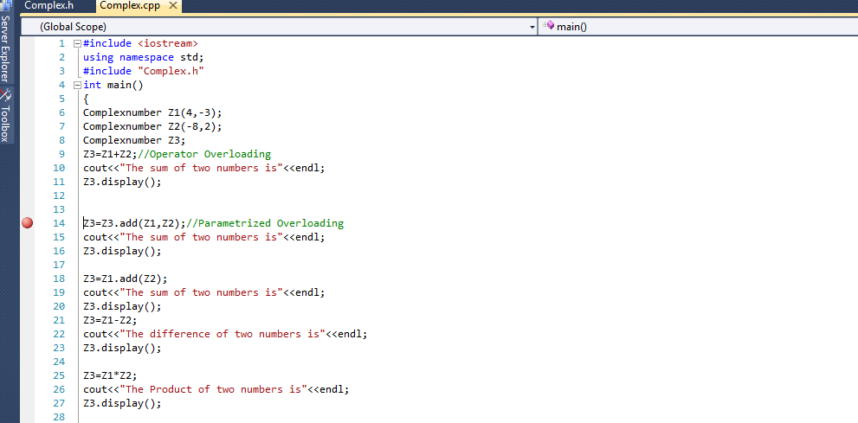

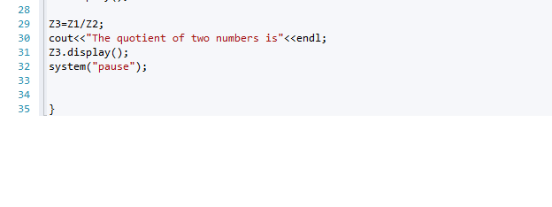

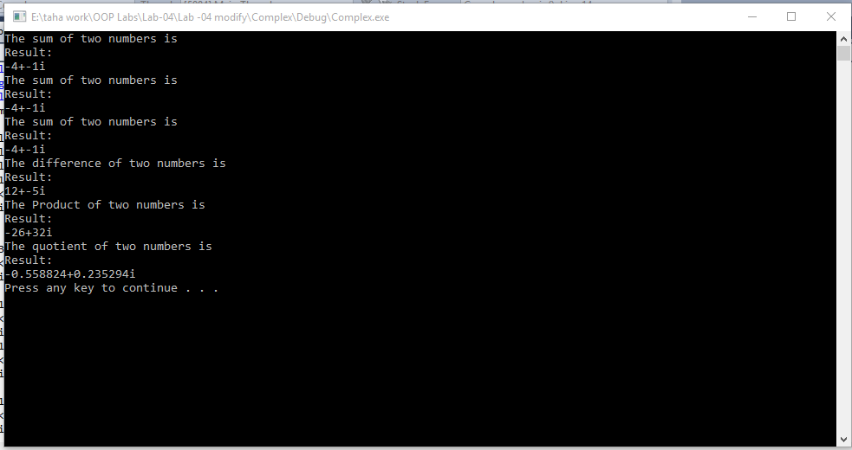

**Debugging**

Jump from Complex.cpp to Complex.h

**Screenshot#1(a)**

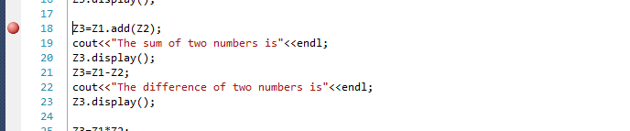

**Screenshot#1(b)**

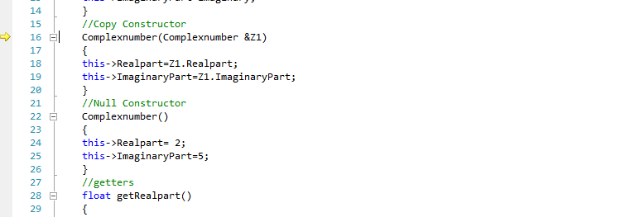

**Screenshot#2(a)**

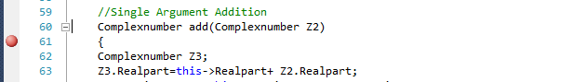

**Screenshot#2(b)**

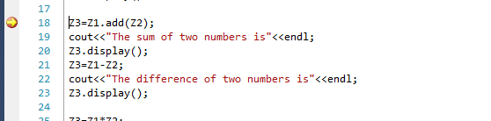

**Screenshot#3(a)**

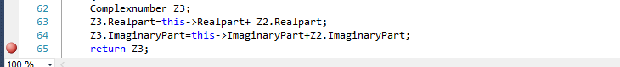

**Screenshot#3(b)**

